Nama : Abdul Rozak A
NIM : 221344033
Kelas : 2B-TNK
Tugas Apl. Komputer dan Basis Data
- Cobalah contoh program JList, JTabbedPane dan JTable yang telah dijelaskan.
package GUI;
import java.awt.*;
import java.awt.event.*;
import javax.swing.*;

public class contohJList implements ActionListener {
public JFrame frame;

public JList list;
public JButton btnTambah, btnHapus;
public JTextField tfItem;
public JScrollPane scroller;

public contohJList() {
tfItem = new JTextField(12);
tfItem.setLocation(10,20);
tfItem.setSize(tfItem.getPreferredSize());

DefaultListModel lm;
lm = new DefaultListModel();
lm.addElement("Java");
lm.addElement("C");
lm.addElement("C++");

list = new JList(lm);
list.setSelectionMode(ListSelectionModel.SINGLE_SELECTION);

scroller = new JScrollPane(list);
scroller.setLocation(10,50);
scroller.setSize(new Dimension(135,170));

btnTambah = new JButton("Tambah");
btnTambah.setLocation(150,17);
btnTambah.setSize(btnTambah.getPreferredSize());
btnTambah.addActionListener(this);
btnTambah.setMnemonic('T');

btnHapus = new JButton("Hapus");
btnHapus.setLocation(150,50);
btnHapus.setSize(btnHapus.getPreferredSize());
btnHapus.addActionListener(this);
btnHapus.setMnemonic('H');
}

public void createAndShowGUI() {
JFrame.setDefaultLookAndFeelDecorated(true);
frame = new JFrame("Demo JList");
frame.setLayout(null);
frame.setDefaultCloseOperation(JFrame.EXIT_ON_CLOSE);

frame.getContentPane().add(tfItem);
frame.getContentPane().add(scroller);
frame.getContentPane().add(btnTambah);
frame.getContentPane().add(btnHapus);

frame.setBounds(0, 0, 430, 350);
frame.setLocationRelativeTo(null);
frame.setVisible(true);
}

public void actionPerformed(ActionEvent event) {
if (event.getSource()==btnTambah) {
String s = tfItem.getText().trim();
if (!s.equals("")) {
((DefaultListModel) list.getModel()).addElement(s);
tfItem.setText("");
}
if(list.getModel().getSize()==1) {
btnHapus.setEnabled(true);
}
}
else {
int index = list.getSelectedIndex();
if (index == -1) {
JOptionPane.showMessageDialog(frame,"Anda harus memilih"
+ "salah satu item terlebih dahulu");
return;
}

((DefaultListModel)list.getModel()).remove(index);

int size = list.getModel().getSize();

if (size==0) {
btnHapus.setEnabled(false);
}
else {
if(index == list.getModel().getSize()) {
index--;
}
list.setSelectedIndex(index);
list.ensureIndexIsVisible(index);
}
}
}

public static void main(String[]args) {
javax.swing.SwingUtilities.invokeLater(new Runnable() {
public void run() {
contohJList app = new contohJList();
app.createAndShowGUI();
}
});
}
}
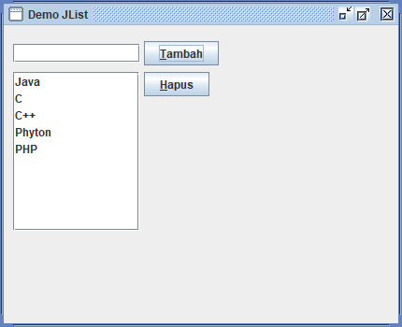
package GUI;
import java.awt.*;
import java.awt.event.*;
import javax.swing.*;

class Page1 extends JPanel implements ActionListener{
private JButton btn;

public Page1() {
btn = new JButton("Info Page #1");
btn.addActionListener(this);
btn.setMnemonic('T');
add(btn);
}

public void actionPerformed(ActionEvent event) {
if(event.getSource()==btn) {
JOptionPane.showMessageDialog(null,"INI ADALAH PAGE KE-1");
}
}
}

class Page2 extends JPanel{
private JTextField tf;

public Page2() {
tf = new JTextField("Ini adalah contoh page kedua...",20);
add(tf);
}
}

public class DemoTabbedPane {
public JTabbedPane tp;

public DemoTabbedPane() {
ImageIcon icon = new ImageIcon();

tp = new JTabbedPane();

tp.addTab("Page #1",icon,new Page1(),"Page pertama");
tp.addTab("Page #2",icon,new Page2(),"Page kedua");

tp.setLocation(0,0);
tp.setSize(new Dimension(290,190));
}

public void createAndShowGUI() {
JFrame.setDefaultLookAndFeelDecorated(true);
JFrame frame = new JFrame("Demo JTabbedPane");
frame.setLayout(null);
frame.setDefaultCloseOperation(JFrame.EXIT_ON_CLOSE);
frame.getContentPane().add(tp);
frame.setBounds(0,0,300,200);
frame.setLocationRelativeTo(null);
frame.setVisible(true);
}

public static void main(String[]args) {
javax.swing.SwingUtilities.invokeLater(new Runnable() {
public void run() {
DemoTabbedPane app = new DemoTabbedPane();
app.createAndShowGUI();
}
});
}
}
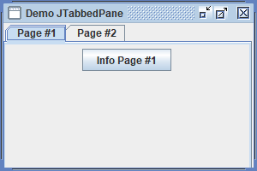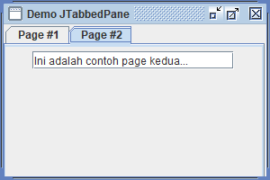

package GUI;
import java.awt.*;
import java.awt.event.*;
import javax.swing.*;

public class DemoTable {
public JTable table;
public JScrollPane scroller;

public DemoTable() {
final String[] judulKolom = {"No.","Nama","Alamat","Kota"};

final Object[][] data = {
{"1","Totok Tribowo","Jl.Melati 12","Cimahi"},
{"2","Desi Mekarsari","Jl. Bunga 333","Bandung"},
{"3","Malik Hendrawan","Jl.Sukamiskin 444","Bandung"},
{"4","Wahyu Suhendi","Jl. Badak 1","Sumedang"},
{"5","Darmanto","Jl. Bawang 23","Brebes"},
{"6","Hendarto","Jl. Pemali 32","Brebes"},
{"7","Kiki Sumantro","Jl. Cipakoma 1","Tegal"},
{"8","Herman Wijanarko","Jl. Macanucul","Tegal"},
{"9","Slamet","Jl. Pakulaut 99","Tegal"},
{"10","Dewi Susanti","Jl. Tukul 99","Semarang"},
{"11","Noni Sumantri","Jl. A Yani 222","Solo"},
{"12","Tedjo Hermanto","Jl. Duren 6","Yogyakarta"},
{"13","Sri Sumarsih","Jl. Melati 5","Surabaya"},
{"14","Eko Waluyo","Jl. Batu 4","Malang"},
{"15","Doni Sandi","Jl. Jeruk 56","Malang"}
};

table = new JTable(data,judulKolom);

scroller = new JScrollPane(table,
ScrollPaneConstants.VERTICAL_SCROLLBAR_AS_NEEDED,
ScrollPaneConstants.HORIZONTAL_SCROLLBAR_AS_NEEDED);
scroller.setLocation(0,0);
scroller.setSize(new Dimension(440,300));
}

public void createAndShowGUI() {
JFrame.setDefaultLookAndFeelDecorated(true);
JFrame frame = new JFrame("Demo JTable");
frame.setLayout(null);
frame.setDefaultCloseOperation(JFrame.EXIT_ON_CLOSE);

frame.getContentPane().add(scroller);

frame.setBounds(0,0,450,350);
frame.setLocationRelativeTo(null);
frame.setVisible(true);
}

public static void main(String[]args) {
javax.swing.SwingUtilities.invokeLater(new Runnable() {
public void run() {
DemoTable app = new DemoTable();
app.createAndShowGUI();
}
});
}
}
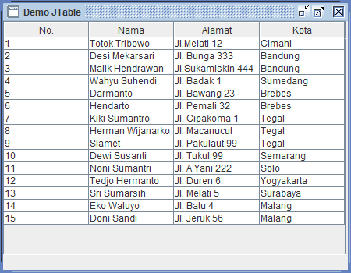
- Dari program JTabbedPane dapat dikembangkan, misal ; membuat program JTabbedPane yang terdiri dari 4 page, dimana page1 berisi form signup, page2 berisi form menu, page3 berisi form pemesanan, page4 berisi form data transaksi.

package GUI2;
import java.awt.*;
import java.awt.event.*;
import javax.swing.*;

class page1 extends JPanel implements ActionListener{
private JLabel lUsername;
private JLabel lPassword;
private JTextField tfUsername;
private JPasswordField pfPass;
private JButton btn;

public page1() {
lUsername = new JLabel("username \t");
add(lUsername);
tfUsername = new JTextField(20);
add(tfUsername);

lPassword = new JLabel("password \t");
add(lPassword);
pfPass = new JPasswordField(20);
pfPass.setEchoChar('*');
add(pfPass);

btn = new JButton("Log In");
btn.addActionListener(this);
add(btn);
}

public void actionPerformed(ActionEvent event) {
if (event.getSource() == btn) {
tabbedPane.tp.setSelectedIndex(1);
}
}
}

class page2 extends JPanel implements ActionListener{
private JComboBox<String> cb;
private JButton btn;

public page2() {
String[] menuItems = {"Nasi Goreng", "Nasi Bakar", "Nasi Lemak", "Nasi Uduk"};
cb = new JComboBox<>(menuItems);
btn = new JButton ("pesan");
btn.addActionListener(this);
add(cb);
add(btn);
}

@Override
public void actionPerformed(ActionEvent e) {
if (e.getSource() == btn) {
tabbedPane.tp.setSelectedIndex(2);
}

}
}

class page3 extends JPanel implements ActionListener {
private JLabel lbl;
private JTextField tf;
private JButton btn;

public page3() {
lbl = new JLabel("Jumlah pesanan");
tf = new JTextField(3);
btn = new JButton ("Pesan");
btn.addActionListener(this);
add(lbl);
add(tf);
add(btn);
}

public void actionPerformed(ActionEvent event) {
if (event.getSource() == btn) {
tabbedPane.tp.setSelectedIndex(3);
}
}
}

class page4 extends JPanel {
private JTextArea ta;

public page4() {
ta = new JTextArea("Terima kasih atas pesanan anda.\n Pesanan anda sedang diproses", 2, 20);
add(ta);
}
}

public class tabbedPane {
public static JTabbedPane tp;

public tabbedPane() {
ImageIcon icon = new ImageIcon();

tp = new JTabbedPane();

tp.addTab("Log In",icon,new page1(),"Sign In");
tp.addTab("Menu",icon,new page2(),"menu");
tp.addTab("Pemesanan",icon,new page3(),"pemesanan");
tp.addTab("Transaksi",icon,new page4(),"transaksi");

tp.setLocation(0,0);
tp.setSize(new Dimension(320,140));
}

public void createAndShowGUI() {
JFrame.setDefaultLookAndFeelDecorated(true);
JFrame frame = new JFrame("Pemesanan Makanan");
frame.setLayout(null);
frame.setDefaultCloseOperation(JFrame.EXIT_ON_CLOSE);
frame.getContentPane().add(tp);
frame.setBounds(0,0,330,150);
frame.setLocationRelativeTo(null);
frame.setVisible(true);
}

public static void main(String[]args) {
javax.swing.SwingUtilities.invokeLater(new Runnable() {
public void run() {
tabbedPane app = new tabbedPane();
app.createAndShowGUI();
}
});
}
}

